INFO 8000 Final project report Lishen Mao

12/8/2017 Geography

Data acquisition:

Four datasets are used to implement this project, including MODIS 17A2 8-day Gross Primary productivity (GPP) dataset, MODIS 11A2 8-day Surface Temperature dataset, MOD09GA daily Land Surface Reflectance (LST) dataset, 30 minutes daily Eddy covariance dataset by flux tower at Grand Bay National Estuarine Research Reserve, Mississippi. MODIS 17A2 8 day GPP dataset, MODIS 11A2 8-day Surface Temperature dataset and MOD09GA daily surface reflectance dataset was downloaded and preprocessed by MODIStsp, it Allows automating the creation of time series of rasters derived from MODIS Satellite Land Products data. It performs several typical preprocessing steps such as download, mosaicking, reprojection and resize of data acquired on a specified time period. All processing parameters can be set using a user-friendly GUI (Figure1). Users can select which layers of the original MODIS HDF files they want to process, which additional Quality Indicators should be extracted from aggregated MODIS Quality Assurance layers and, in the case of Surface Reflectance products, which Spectral Indexes should be computed from the original reflectance bands. For each output layer, outputs are saved as single-band raster files corresponding to each available acquisition date. Virtual files allowing access to the entire time series as a single file are also created. Command-line execution exploiting a previously saved processing options file is also possible, allowing to automatically update time series related to a MODIS product whenever a new image is available (cite information).

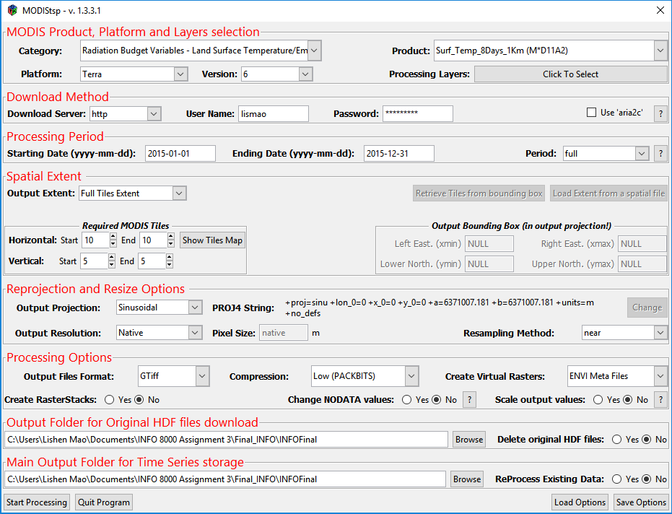

The MODIS land products are produced at 4 resolutions (250m, 500m, 1km, and 0.05 degree) In order to maintain reasonable file sizes for the other higher resolution MODIS land data products, each projection is divided up into a tiled grid. The land products are thus produced and distributed in adjacent non-overlapping tiles that are approximately 10 degrees square (at the equator). Most of MODIS land products are produced in the Sinusoidal tile grid (cite). My study site located in the red circled grid with horizontal tile 10; vertical tile 5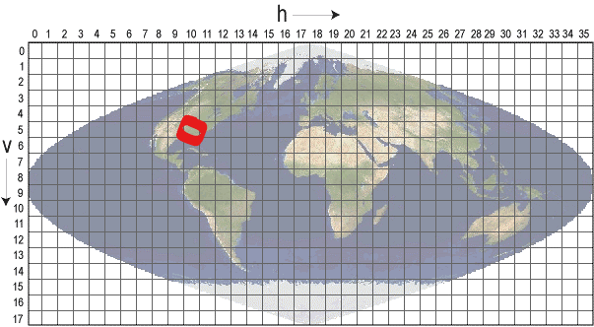

Eddy covariance flux tower was set up by previous graduate student and project investigator. It locates at latitude 30.369073° longitude -88.417211° in Sinusoidal projection system and GCS_WGS_1984 Geographic Coordinate System. Eddy covariance data comes with a lot of missing value due to instrument running problem and calculation error, for example (figure 2). Therefore I first deleted gpp value equals to -9999 and then picked the exact day that matches 8-day interval MODIS GPP and Land surface temperature datasets. Therefore my dataset should include 46 rows (attributes) from day 1 to day 361 of 2015, including days of 1, 9 , 17, 25, 33, 41, 49, 57, 65, 73, 81, 89, 97, 105, 113, 121, 129, 137, 145, 153, 161, 169, 177, 185, 193, 201, 209, 217, 225, 233, 241, 249, 257, 265, 273, 281, 289, 297, 305, 313, 321, 329, 337, 345, 353, 361. However due to missed data in EC measurement dataset, I eventually only have 36 rows(attributes), which are days of 25, 33, 41, 49, 57, 65, 73, 81, 145, 153, 161, 169, 177, 185, 193, 201, 209, 217, 225, 233, 241, 249, 257, 265, 273, 281, 289, 297, 305, 313, 321, 329, 337, 345, 353, 361. Remote sensed GPP and LST data was extracted by using “Extract multi values to points” spatial analyst tool in ArcGIS. I also exercised using R to extract values for flux tower site pixel from GPP and LST dataset. EVI was calculated by formula: 2.5 * (RNir – RRed/1+RNir + 6*RRed-7.5*RBlue), while near inferred (RNir) is band 2, Red (RRed) is band 1 and Blue (RBlue) in MOD09GA surface reflectance dataset. I also used the similar strategy to select specific EVI value of date out to match 8-day MODIS GPP and LST data. I also changed unit from µmol/(s*m2) in eddy coviance dataset to match G/cm2 in remote sensing GPP dataset. The formula is g/cm2 = µmol/(s*m2) / 1000000 / 0.022722366761722 * 1000000.

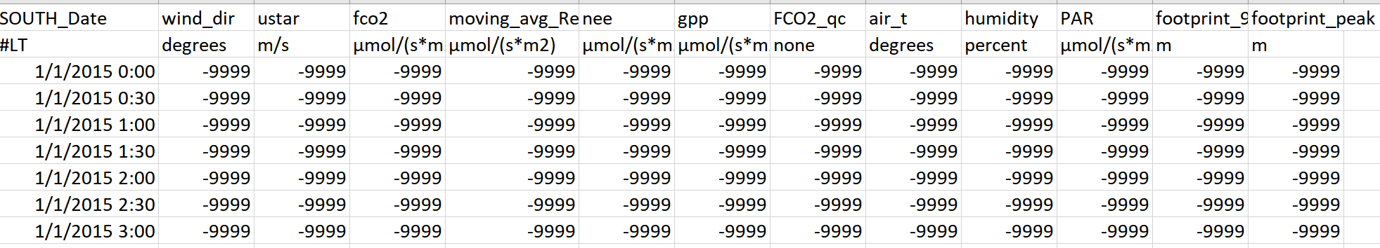

(Figure 2: missing data in EC measurement dataset)

Temperature & Greenness model:

The Temperature and Greenness (TG) model was developed by Sims et al. (2008) that based on the Enhanced Vegetation Index (EVI) and the Land Surface Temperature (LST) products from MODIS. The TG model equals GPP ∝ ScaledEVI * ScaledLST, where ScaledEVI = EVI – 0.1 because previous studies by Sims et al (2016) suggested that GPP drops to zero when an EVI value of 0.1. ScaledLST is defined as Min[(LST/30:(2.5-(0.05*LST)].

Result

Reference

L. Busetto, L. Ranghetti (2016) MODIStsp: An R package for automatic preprocessing of MODIS Land Products time series, Computers & Geosciences, Volume 97, Pages 40 48, ISSN 0098-3004, http://dx.doi.org/10.1016/j.cageo.2016.08.020. URL https://github.com/lbusett/MODIStsp/.

Sims, D. A., Rahman, A. F., Cordova, V. D., El-Masri, B. Z., Baldocchi, D. D., Flanagan, L. B., et al. (2006).On the use of MODISEVI to assess gross primary productivity of North American ecosystems. Journal of Geophysical Research, 111, G04015. doi:10.1029/2006JG000162.